**Study and prototyping of plastic waste recycling into 3D printer filament**

***CHITTAMPALLI ASHRITHA(19951A0308)***

***JAMMULA MANASKANTH(19951A0327)***

***KOTHAPALLI PRANAY TAJA(19951A0337)***

**Study and prototyping of plastic waste recycling into 3D printer filament**

A project Report

Submitted in partial fulfillment of the Requirements for the award of the degree of

## Bachelor of Technology in

**MECHANICAL ENGINEERING**

by

## CHITTAMPALLYASHRITHA(19951A0308) JAMMULA MANASKANTH(19951A0327) KOTHAPALLI PRANAY TEJA(19951A0337)

Under the guidance of

## C. LABESH KUMAR



**Department by Mechanical Engineering**

**INSTITUTE OF AERONAUTICAL ENGINEERING**

## (Autonomous)

**Dundigal, Hyderabad – 500 043, Telangana**

## January, 2023

All rights reserved

## DECLARATION

I certify that

1. The work contained in this report is original and has been done by me under the guidance of my supervisor(s).
2. The work has not been submitted to any other Institute for any degree or diploma.
3. I have followed the guidelines provided by the Institute in preparing the report.
4. I have conformed to the norms and guidelines given in the Ethical Code of Conduct of the Institute.
5. Whatever I have used materials (data, theoretical analysis, figures, and text) from other sources, I have given due credit to them by citing them in the text of the report and giving their details in the references. Further, I have taken permission from the copyright owners of the sources, wherever necessary.

Place: Signature of the student

Date: Roll No: 19951A0308

19951A0327

19951A0302

## CERTIFICATE

This is to certify that the project report entitled **Study and prototyping of plastic waste recycling into 3D printer filament** submitted by **CHITTAMPALLYASHRITHA, JAMMULAMANASKANTH, KOTHAPALLI PRANAY TEJA** to the Institute of Aeronautical engineering, Hyderabad, in partial fulfillment of the requirements for the award of the Degree Bachelor of Technology in **Mechanical Engineering** is a bonafide record of work carried out by him/her under my/our guidance and supervision. In whole or in parts, the contents of this report have not been submitted to any other institute for the award of any Degree.

**Supervisor Head of the Department**

**C. LABESH KUMAR Dr. V.V.S.H Prasad Professor, ME**

**Date:**

## APPROVAL SHEET

This project report entitled **Study and prototyping of plastic waste recycling into 3D printer filament** by **CHITTAMPALLY ASHRITHA, JAMMULA MANASKANTH, KOTHAPALLI PRANAY TEJA** is approved for the award of the Degree Bachelor of Technology in Mechanical Engineering.

**Examiner Supervisor (s)**

**C. LABESH KUMAR.**

**Principal**

**Dr. L V Narasimha Prasad**

**Date: Place:**

## ACKNOWLEDGEMENT

Without mentioning people who have made it through their guidance and encouragement all efforts to be achieved, the successful completion of any task would be incomplete. I am grateful to **C.LABESH KUMAR** , for their constant encouragement and valuable guidance during project work, and I am grateful for his deep gratitude in this collaboration to bring this project report to a successful end, to our head of the Department of Mechanical Engineering, **Dr. V. V. S. H PRASAD**. I am delighted to express our sincere thanks to **Dr. L. V. Narasimha Prasad**, our principal and professor, who has ignited and has given a successful way to our hidden potential, built up career, inculcated confidence, sincerity and discipline.

## ABSTRACT

Disposal of plastic is major concern in today’s world more than 20 % of plastic is due to the plastic bottles. Reusing of plastic materials enables effective waste utilization to obtain consumable products. An attempt is made to design and fabricate a machine which converts PET bottles in to raw material for 3D printing .The input raw material is blended with other raw material to form a proper filament for 3D printing machine to create different prototypes. Printable filaments can be made from a plastic materials . This paper focuses on a review of the available literature on the production of filaments for

3D printers from recycled polymers as the alternative to present approach of central selective collection of plastics.3D printing is a form of additive manufacturing technology where a 3D object is created by laying down successive layers of material. It is mechanized method whereby 3D objects are quickly made on a reasonably sized machine connected to a computer containing blueprints for the object.

As 3D printing is growing fast and giving a boost to product development, the factories doing

3D printing need to continuously meet the printing requirements and maintain an adequate amount of inventory of the filament.

KEYWORDS:3D printing, Design, Fabrication, Plastic composite, Recycle.

**LIST OF CONTENTS**

|  |  |
| --- | --- |
| COVER PAGE | 1 |
| INSIDE COVER PAGE | 2 |
| DECLARATION | 3 |
| CERTIFICATE | 4 |
| APPROVAL SHEET | 5 |
| ACKNOWLEDGEMENT | 6 |
| ABSTRACT | 7 |
| LIST OF CONTENTS | 8 |

|  |  |
| --- | --- |
| CHAPTER 1: INTRODUCTION | 9 |
| 1.1 INTRODUCTION | 10 |
|  |  |
| CHAPTER 2:   * 1. DESIGN AND IMPLEMENTATION   2. CONSTRUCTION AND WORKING | 13 |
| CHAPTER 3: LITERATURE SURVEY | 15 |
| CHAPTER 4: METHODOLOGY | 16 |
| REFERENCES | 17 |

# CHAPTER 1 INTRODUCTION

**1.1 INTRODUCTION**

* Plastic pollution is the accumulation of plastic objects and particles (e.g., plastic bottles, bags) in the Earth's environment that adversely affects humans, wildlife and their habitat.
* Plastics that act as [pollutants](https://en.wikipedia.org/wiki/Pollutant) are categorized by size into micro-, or macro debris. Plastics are inexpensive and durable, making them very adaptable for different uses; as a result, manufacturers choose to use plastic over other materials.
* The chemical structure of most plastics renders them resistant to many natural processes of [degradation](https://en.wikipedia.org/wiki/Environmental_degradation) and as a result they are slow to degrade. Together, these two factors allow large volumes of plastic to enter the environment as mismanaged waste and for it to persist in the [ecosystem.](https://en.wikipedia.org/wiki/Ecosystem)
* A method to convert a commonly thrown-away plastic to a resin used in 3D-printing could allow for making better use of plastic waste. Fused Deposition Modelling (FDM) is the most common 3D printing technology.
* An object formed through continuous layering until completion is known as an additive process. 3D printing is a very popular way of fast prototyping, making fully usable models.
* A longstanding goal in the 3D printing community is plastic recycling, both for failed prints and waste plastic from water bottles and other sources. Because FFF (Fused-Filament Fabrication) 3D printers use filament made from thermoplastic, we could theoretically make use of much of the plastic that would otherwise end up in a landfill. But in reality, recycling plastic into usable filament has proven to be very difficult for a variety of reasons that works with PET bottles and fabrication machine.
* The user loads up an old water bottle made of PET (a very common plastic) and cuts a small strip to start. They then feed that through a hot end that melts the plastic strip and extrudes round filament.
* Once a little bit of extruded filament comes out, the user attaches that to a spool that mounts onto a motorized hub. From then on, the motor will spin and pull the filament onto the spool. The idea is that people should end up with a spool of PET filament that they can then print like any other filament.
* The aim of this work was to review the possibility of reusing polymeric materials for 3D printing. The attention was paid to the recycling potential, existing commercial solutions, and programs related to the promotion of the idea of reuse of waste materials.
* The most commonly used technology in this process is FFF. In this technology, a plastic filament or metal wire is unwound from a coil and supplied to an extrusion [nozzle](https://www.sciencedirect.com/topics/materials-science/nozzle) which can turn the flow on and off.

The nozzle is heated to melt the material and can be moved in both horizontal and vertical directions by a numerically controlled mechanism, directly controlled by a computer-aided manufacturing (CAM) software package.

The object is produced by extruding layers of melted material that solidify upon cooling immediately after extrusion from the nozzle .

**DESIGN AND IMPLEMENTATION**

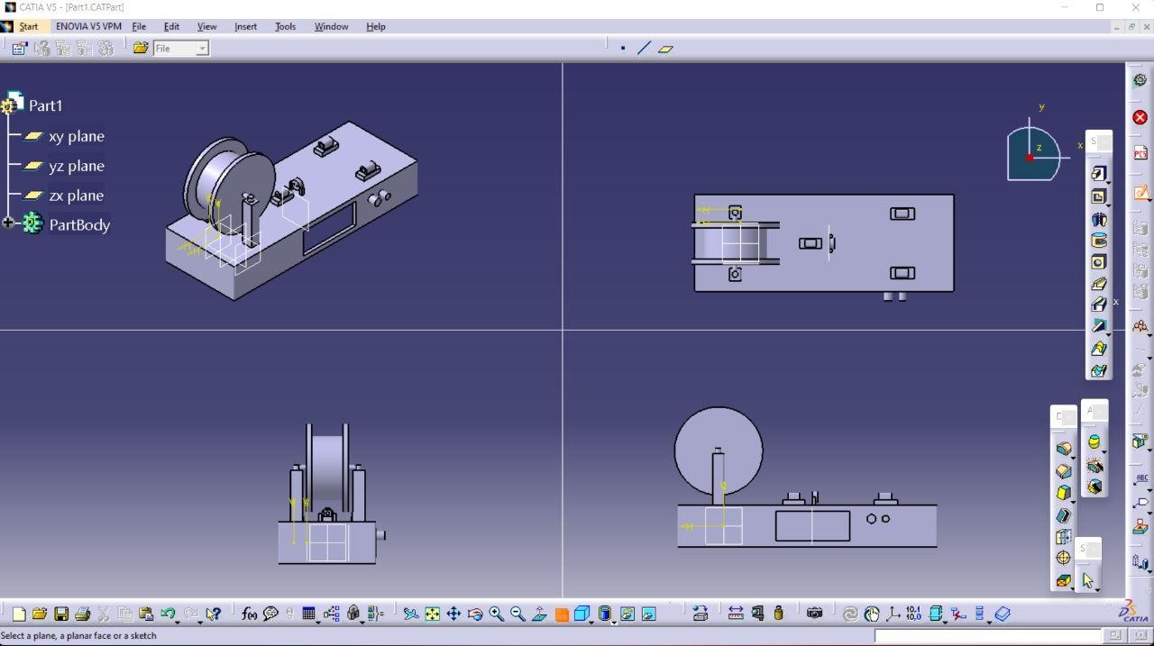

**CONSTRUCTION AND WORKING**

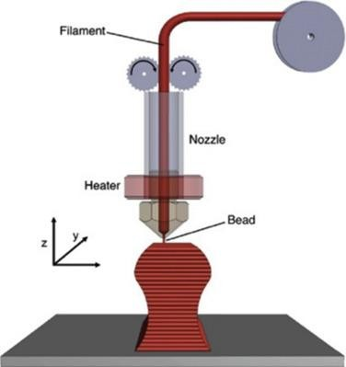

* The machine is made of simple mechanical parts. Every part is mounted to the machine by screws in properly designed places.
* Then we have cut the base of bottle horizontally with the cutter. We have to give a cut of 10mm to the bottle at bottom in a specific angle range between 20° to 40°.
* Insert the pointed portion into cutter slot of 6mm or 8mm depending upon the thickness of the

bottle respectively. Pull the pointed portion from other side of the cutter with plyer. With the help of plyer insert the strip into the extruder and push the strip inside till it the comes out from the exit of nozzle.

* Let the filament cool and then slowly pull the filament with the plyer till it reaches the winding spool. Tie the filament to winding spool with help of wire. Now the filament will start winding automatically.

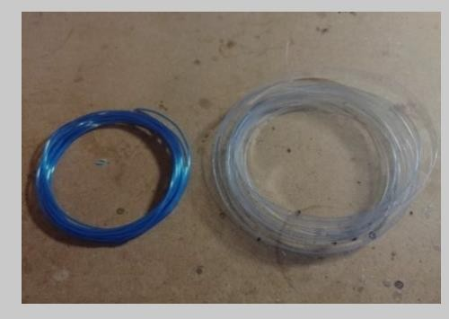

* There is PET bottle cutter which cuts the bottle into a narrow strip. A narrowed plastic strip should be inserted through the cold nozzle power supply, which will greatly facilitate the initial extrusion of the filament through the nozzle, the next step is connecting the power supply.
* After that, the switch on the side of the case should be switched on. Activated universal temperature controller is now extruder to set temperature 250°C, and this temperature was chosen experimentally. When the extruder reaches set temperature, the plastic strip should be drawn manually until you can attach it to the spool.
* Now by switching on and regulating rotation of spool, the molten plastic is forced through the hothead, then cooled and hardened, and then wound on a spool.

**CHAPTER3**

# LITERATURE SURVEY

1. **3D printing filament as a second life of waste plastics-**Polymer materials have been found an application in many areas of daily life and industry. Along with their extended use, the problem of plastic wastes appeared because, after withdrawal from use, they became persistent and noxious wastes. The possibility of reusing polymeric materials gives a possibility of valorization—a second life—and enables effective waste utilization to obtain consumable products. The 3D printing market is a well- growing sector. Printable filaments can be made from a variety of thermoplastic materials, including those from recycling. This paper focuses on a review of the available literature on the production of filaments for 3D printers from recycled polymers as the alternative to present approach of central selective collection of plastics.
2. **Development of 3D Printing Raw Materials from Plastic Waste-**Fused Deposition Modelling (FDM) is the most common 3D printing technology. An object formed through continuous layering until completion is known as an additive process while other processes with different methods are also

relevant. In this paper, mechanical properties were analyzed using two distinct kinds of printed polyethylene terephthalate (PET) as tensile test specimens. The materials used consist of recycled PET and virgin

PET. An assessment of all the forty test pieces of both kinds of PET was undertaken. A comparison of the test samples’ tensile strength values, difference in stress-strain curves, and elongation at break was also carried out. The reasoning behind the fracturing of test pieces that printed with different settings is presented in part by the depiction of the fractured specimens following the tensile test. An optimal route was revealed to be 3D printing with recycled PET, as per the mechanical testing.

1. **Filament for a 3D Printer from Pet Bottles Simple Machine-**the process of preparation of the material from bottles, also mechanical construction created mostly from 3D printed parts. The second part of the article shows an electrical and electronic system, that is responsible for temperature controlling, filament winding speed control, head cooling and heating. The third part of the article shows the filament creation process and machine operation.
2. **Construction Of Plastic Waste Extruding Machine To Produce Filaments Of 3D Printing Machine**- design and development of plastic waste extruding machine to provide 3D printing filaments. The motivation of this research is to create a 3d printer filament from plastic waste using simple machine components. In addition, another goal is to create valuable items from plastic waste. The research process begins with design, needs analysis, machine rebuilding and electrical assembly, machine function testing, analysis of filament, and filament testing in 3D printing machine. The categories of shredded plastic material were plastic cups (polypropylene, PP) and a mixture of plastic bottles (polyethylene terephthalate, PET) and plastic cups (polypropylene, PP). The analysis of the research was the capacity of the extrusion machine, the best temperature in producing filaments based on shapes and sizes, and testing of 3D printing filaments of plastic waste which was applied to the 3D printing machine. The result showed that 190°C was the greater temperature to heat the barrel, machine capacity of each plastic waste category, and the characteristic plastic waste was almost similar compared to market filament of polylactic acid (PLA) in terms of filament size and 3D printing machine parameter.
3. **Materials selection of 3D printing filament and utilization of recycled polyethylene terephthalate (PET) in a redesigned breadboard**-The demand for a novel and sustainable alternative materials for 3D printer filaments has been knowingly increasing. One alternative source for the filament is to reuse and recycle post-consumer plastic products, which is also a compelling approach to conserve energy and sustain the environment. Thus, this study is focused on the materials selection of virgin polymer resins and recycled post-consumer plastics for use in 3D printer filaments. A multi-criteria decision method of Elimination and Choice Expressing the Reality (ELECTRE) was utilized to determine the best materials

for 3D printer filaments. The study has shown that the virgin low-density polyethylene (LDPE) and recycled polyethylene terephthalate (PET) are optimal materials as an alternative filament among other options such as virgin high-density polyethylene (HDPE),virgin polypropylene (PP) and recycled HDPE. Aside from the different options of the type of materials, the various properties considered in the calculation include tensile strength, melting point, glass transition temperature, melt flow index, coefficient of

thermal expansion, and cost.

1. **Development of a low-cost prototype of an extruder for plastic waste-**. Plastic waste is one of the biggest environmental problems worldwide, including in Indonesia. A community based initiative such as the waste bank is seen by many as a potential player contributing toward the alleviation of the problem. However, their sustainability in operation is very dependent on the plastic selling price which constantly fluctuates. The conversion of plastic waste, such as polyethylene terephthalate (PET) into a higher value product by the use

of a shredder and an extruder can help this matter. An extruder is a machine which can produce plastic filaments by applying a heat to the inputted shredded plastic wastes. In this work, a simple, low-cost extruder designed to be suitable to the condition of the developing nations is developed. A simple control system is applied to the system for a better temperature output. The produced filament is evaluated for consistency

of density and diameter under varied temperature. The optimum temperature found is 2000C and the produced filament is observed to be within a reasonable degree of consistency in terms of diameter with an error in

the range of 20%.

**[7]Short basalt fiber reinforced recycled polypropylene filaments for 3D printing-**Additive Manufacturing (3D Printing, and specifically Material Extrusion) is a rapid and convenient manufacturing method using raw material in filament form and is a potential candidate process for the use of recycled plastics and fibers gathered from industrial waste and domestic recycling. In this research, off-cuts of basalt fiber and recycled mushroom trays made of Polypropylene (PP) have been collected, recycled and combined in an extruder to make short fiber reinforced filaments as material extrusion feedstock filament material.

**[11]Manufacturing of a PET Filament from Recycled Material for Material Extrusion (MEX)-**Due to its low cost and easy use, the use of material extrusion (MEX) as an additive manufacturing (AM) technology has increased rapidly in recent years. However, this process mainly involves the processing of new plastics.

Combining the MEX process with polyethylene terephthalate(PET), which offers a high potential for mechanical and chemical recyclability, opens up a broad spectrum of reutilization possibilities. Turning used PET bottles into printable filament for MEX is not only a recycling option, but also an attractive upcycling scenario that can lead to the production of complex, functional parts. This work analyzes the process of extruding recycled PET bottle flakes into a filament, taking different extrusion screws and extrusion parameters into account. The filament is subsequently processed with MEX into tensile tests.

# CHAPTER4 METHODOLOGY

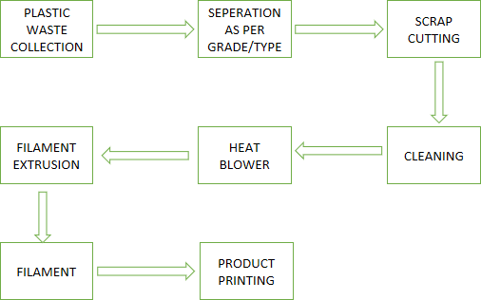

**CHAPTER 5 REFERENCES**

[1]**3D printing filament as a second life of waste plastics**—a review Katarzyna Mikula1 & Dawid Skrzypczak1 & Grzegorz Izydorczyk1 & Jolanta Warchoł1 & Konstantinos Moustakas2 & Katarzyna Chojnacka1 & Anna Witek-Krowiak1.

1. **Development of 3D Printing Raw Materials from Plastic Waste.A Case Study on Recycled Polyethylene Terephthalate** Alaeddine Oussai 1,* , Zoltán Bártfai 2 and László Kátai 1.
2. **Filament for a 3D Printer from Pet Bottles Simple Machine** Igor Tylman and Kazimierz Dzierżek Department of Robotics and Mechatronics, Faculty of Mechanical Engineering, Bialystok University of Technology, Bialystok, Poland.
3. **Construction Of Plastic Waste Extruding Machine To Produce Filaments Of 3D Printing Machine** Muhammad Luthfi Sonjaya Polytechnic ATI Makassar: Politeknik ATI Makassar Mutmainnah Mutmainnah Polytechnic ATI Makassar: Politeknik ATI Makassar Muh Farid Hidayat Polytechnic ATI Makassar: Politeknik ATI Makassar.
4. Mark, C. Julie, M. Jill and M. Eduardo, "**Materials selection of 3D printing filament and utilization of recycled polyethylene terephthalate (PET) in a redesigned breadboard**", 29th CIRP Design Conference CIRP Design, vol. 84, pp. 28-32, 2019.

[6]S. Daniel, L. Damal and K. Raldi, "**Development of a low-cost prototype of an extruder for plastic waste**", 16th International Conference on Quality in Research, vol. 2227, 2019.

[7]Pouyan, F. Tomas and H. Noel, **"Short basalt fibre reinforced recycled polypropylene filaments for 3D printing"**, vol. 326, 2022.

[8]N. E. Zander, M. Gillan, Z. Burckhard, and F. Gardea, **“Recycled polypropylene blends as novel 3D printing materials”** Additive Manufacturing, vol. 25, pp. 122–130, Jan. 2019.

[9]S. Daniel, L. Damal and K. Raldi, **"Development of a low-cost prototype of an extruder for plastic waste",** 16th International Conference on Quality in Research, vol. 2227, 2019.

1. **Fabrication of Extrudate Filaments from Waste Polyethylene Terephthalate Plastics for 3D Printers** Favour C. Eboh, Opeyemi Osideko, and Modupe Onitiri Department of Mechanical Engineering, University of Lagos, Nigeria 10-MAY-2021
2. **Manufacturing of a PET Filament from Recycled Material for Material Extrusion (MEX)**Maximilian Bustos Seibert 1, Gerardo Andres Mazzei Capote 2, Maximilian Gruber 3, Wolfram Volk 3 and Tim A. Osswald 2.
3. Europe Plastics. **Plastics**—The facts 2021. Plast. Eur. 2021, 1, 1–34.